# De 13 Deltawerken

**[Bathse Spuisluis](https://watersnoodmuseum.nl/kennisbank/bathse-spuisluis/" \t "_self)**

[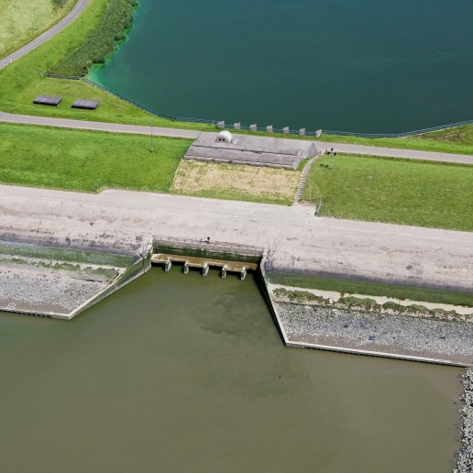](https://watersnoodmuseum.nl/kennisbank/bathse-spuisluis/)

**[Hollandse IJsselkering](https://watersnoodmuseum.nl/kennisbank/hollandse-ijsselkering/" \t "_self)**

[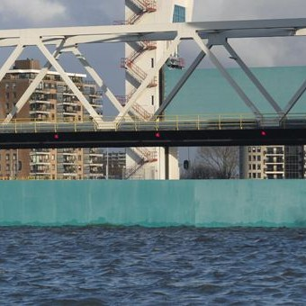](https://watersnoodmuseum.nl/kennisbank/hollandse-ijsselkering/)

**[Markiezaatkade](https://watersnoodmuseum.nl/kennisbank/markiezaatkade/" \t "_self)**

[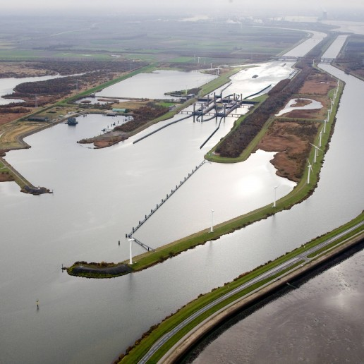](https://watersnoodmuseum.nl/kennisbank/markiezaatkade/)

**[Maeslantkering](https://watersnoodmuseum.nl/kennisbank/maeslantkering/" \t "_self)**

[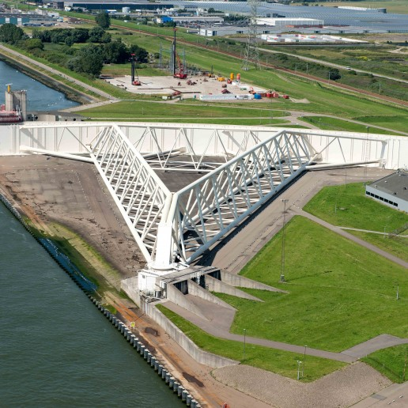](https://watersnoodmuseum.nl/kennisbank/maeslantkering/)

**[Oesterdam](https://watersnoodmuseum.nl/kennisbank/oesterdam/" \t "_self)**

[[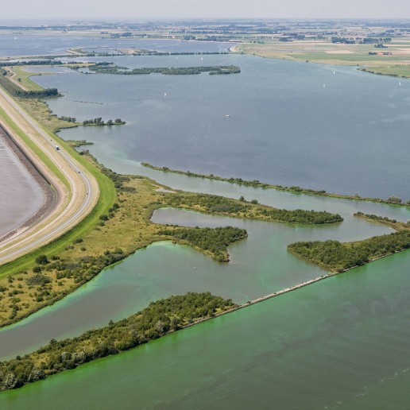](https://watersnoodmuseum.nl/kennisbank/oesterdam/)](https://watersnoodmuseum.nl/kennisbank/krammersluizen/" \t "_self)

**[Krammersluizen](https://watersnoodmuseum.nl/kennisbank/krammersluizen/" \t "_self)**

[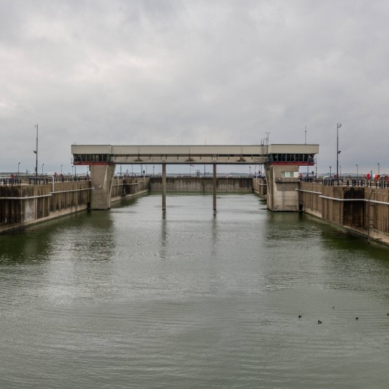](https://watersnoodmuseum.nl/kennisbank/krammersluizen/)

**[Philipsdam](https://watersnoodmuseum.nl/kennisbank/philipsdam/" \t "_self)**

[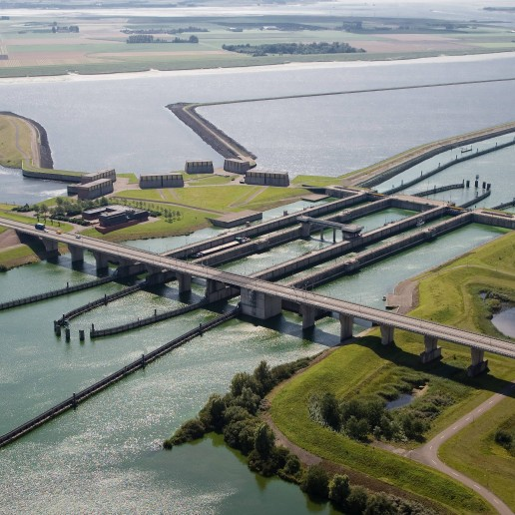](https://watersnoodmuseum.nl/kennisbank/philipsdam/)

**[Volkerak](https://watersnoodmuseum.nl/kennisbank/volkerak/" \t "_self)**

[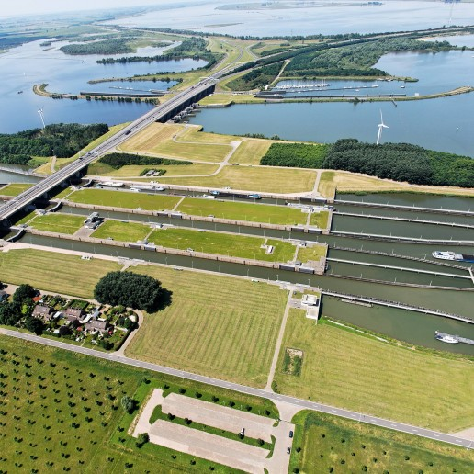](https://watersnoodmuseum.nl/kennisbank/volkerak/)

**[Haringvlietdam](https://watersnoodmuseum.nl/kennisbank/haringvlietdam/" \t "_self)**

[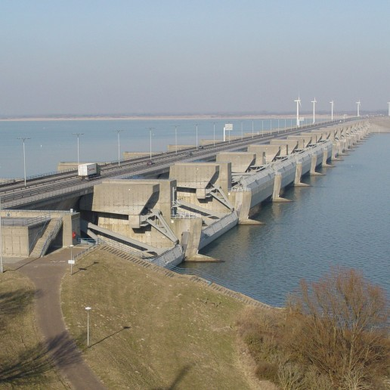](https://watersnoodmuseum.nl/kennisbank/haringvlietdam/)

**[Grevelingendam](https://watersnoodmuseum.nl/kennisbank/grevelingendam/" \t "_self)**

[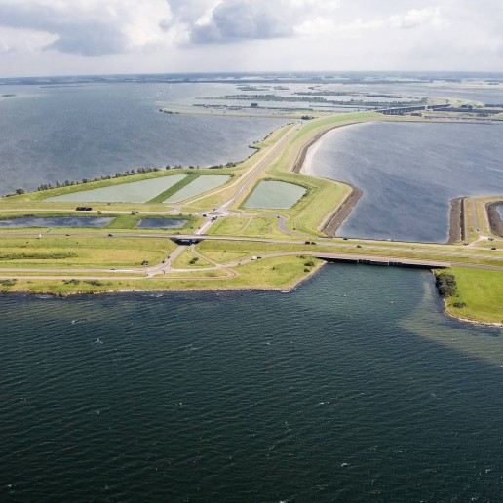](https://watersnoodmuseum.nl/kennisbank/grevelingendam/)

**[Veerse Gatdam](https://watersnoodmuseum.nl/kennisbank/veerse-gatdam/" \t "_self)**

[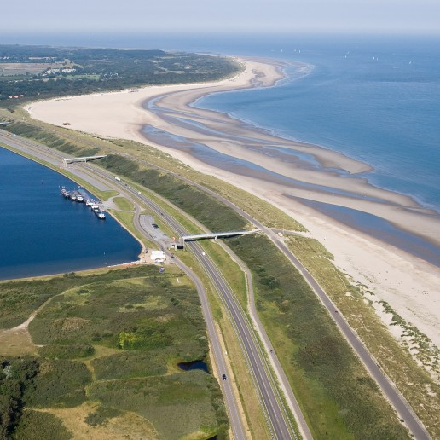](https://watersnoodmuseum.nl/kennisbank/veerse-gatdam/)

**[Brouwersdam](https://watersnoodmuseum.nl/kennisbank/brouwersdam/" \t "_self)**

[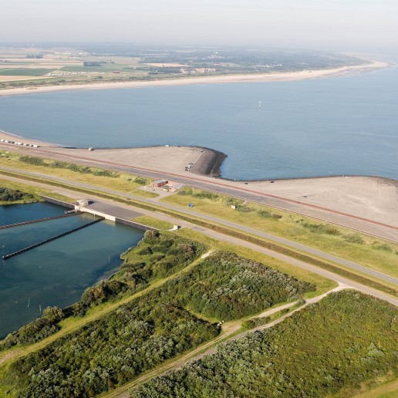](https://watersnoodmuseum.nl/kennisbank/brouwersdam/)

**[Zandkreekdam](https://watersnoodmuseum.nl/kennisbank/zandkreekdam/" \t "_self)**

[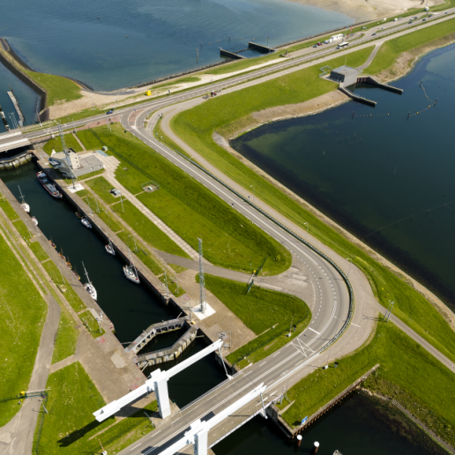](https://watersnoodmuseum.nl/kennisbank/zandkreekdam/)

**[Oosterscheldekering](https://watersnoodmuseum.nl/kennisbank/oosterscheldekering/" \t "_self)**

[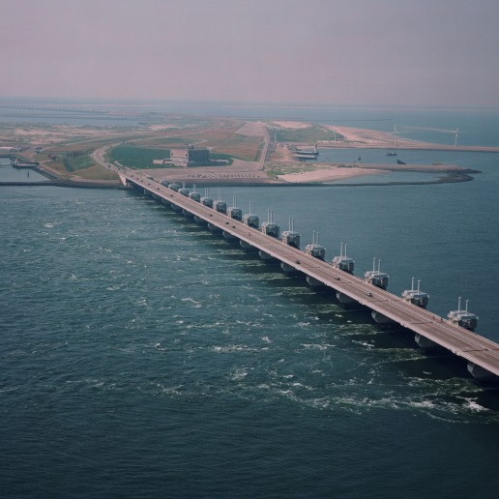](https://watersnoodmuseum.nl/kennisbank/oosterscheldekering/)

**[Hartelkering](https://watersnoodmuseum.nl/kennisbank/hartelkering/" \t "_self)**

[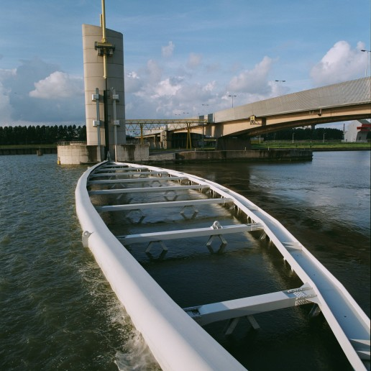](https://watersnoodmuseum.nl/kennisbank/hartelkering/)